Base de datos

Actividad 3

1.

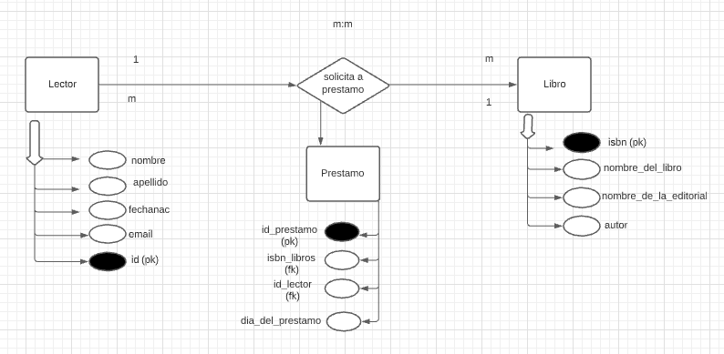

2.

INSERT INTO prestamo (id_lector, isbn_libros, dia_del_prestamo, id_prestamo) VALUES('1', '2225412', '2021/3/15', DEFAULT);

INSERT INTO prestamo (id_lector, isbn_libros, dia_del_prestamo, id_prestamo) VALUES('4', '2225412', '2021/3/20', DEFAULT);

INSERT INTO prestamo (id_lector, isbn_libros, dia_del_prestamo, id_prestamo) VALUES('9', '7788845', '2021/3/22', DEFAULT);

INSERT INTO prestamo (id_lector, isbn_libros, dia_del_prestamo, id_prestamo) VALUES('7', '4568874', '2021/3/22', DEFAULT);

INSERT INTO prestamo (id_lector, isbn_libros, dia_del_prestamo, id_prestamo) VALUES('2', '22545447', '2021/3/25', DEFAULT);

INSERT INTO prestamo (id_lector, isbn_libros, dia_del_prestamo, id_prestamo) VALUES('6', '2225412', '2021/3/25', DEFAULT);

INSERT INTO prestamo (id_lector, isbn_libros, dia_del_prestamo, id_prestamo) VALUES('8', '22545447', '2021/3/25', DEFAULT);

INSERT INTO prestamo (id_lector, isbn_libros, dia_del_prestamo, id_prestamo) VALUES('10', '44558877', '2021/3/30', DEFAULT);

INSERT INTO prestamo (id_lector, isbn_libros, dia_del_prestamo, id_prestamo) VALUES('5', '4568874', '2021/3/30', DEFAULT);

INSERT INTO prestamo (id_lector, isbn_libros, dia_del_prestamo, id_prestamo) VALUES('5', '2564111', '2021/3/30', DEFAULT);

INSERT INTO prestamo (id_lector, isbn_libros, dia_del_prestamo, id_prestamo) VALUES('6', '5544781', '2021/4/1', DEFAULT);

INSERT INTO prestamo (id_lector, isbn_libros, dia_del_prestamo, id_prestamo) VALUES('2', '5544781', '2021/4/5', DEFAULT);

INSERT INTO prestamo (id_lector, isbn_libros, dia_del_prestamo, id_prestamo) VALUES('1', '88541254', '2021/4/5', DEFAULT);

INSERT INTO prestamo (id_lector, isbn_libros, dia_del_prestamo, id_prestamo) VALUES('9', '7787898','2021/4/5', DEFAULT);

INSERT INTO prestamo (id_lector, isbn_libros, dia_del_prestamo, id_prestamo) VALUES('1', '2564111', '2021/4/5', DEFAULT);

INSERT INTO prestamo (id_lector, isbn_libros, dia_del_prestamo, id_prestamo) VALUES('4', '88541254', '2021/4/6', DEFAULT);

INSERT INTO prestamo (id_lector, isbn_libros, dia_del_prestamo, id_prestamo) VALUES('10', '7788845', '2021/4/6', DEFAULT);

INSERT INTO prestamo (id_lector, isbn_libros, dia_del_prestamo, id_prestamo) VALUES('6', '7787898', '2021/4/6', DEFAULT);

INSERT INTO prestamo (id_lector, isbn_libros, dia_del_prestamo, id_prestamo) VALUES('10', '7787898', '2021/4/6', DEFAULT);

INSERT INTO prestamo (id_lector, isbn_libros, dia_del_prestamo, id_prestamo) VALUES('5', '7787898', '2021/4/6', DEFAULT);

INSERT INTO prestamo (id_lector, isbn_libros, dia_del_prestamo, id_prestamo) VALUES('2', '44558877', '2021/4/7', DEFAULT);

INSERT INTO prestamo (id_lector, isbn_libros, dia_del_prestamo, id_prestamo) VALUES('4', '5544781', '2021/4/7', DEFAULT);

INSERT INTO prestamo (id_lector, isbn_libros, dia_del_prestamo, id_prestamo) VALUES('1', '4568874', '2021/4/7', DEFAULT);

INSERT INTO prestamo (id_lector, isbn_libros, dia_del_prestamo, id_prestamo) VALUES('10', '88541254', '2021/4/9', DEFAULT);

INSERT INTO prestamo (id_lector, isbn_libros, dia_del_prestamo, id_prestamo) VALUES('6', '2564111', '2021/4/9', DEFAULT);

INSERT INTO prestamo (id_lector, isbn_libros, dia_del_prestamo, id_prestamo) VALUES('9', '2564111', '2021/4/9', DEFAULT);

INSERT INTO prestamo (id_lector, isbn_libros, dia_del_prestamo, id_prestamo) VALUES('5', '88541254', '2021/4/10', DEFAULT);

INSERT INTO prestamo (id_lector, isbn_libros, dia_del_prestamo, id_prestamo) VALUES('10', '2225412', '2021/4/10', DEFAULT);

INSERT INTO prestamo (id_lector, isbn_libros, dia_del_prestamo, id_prestamo) VALUES('1', '7788845', '2021/4/15', DEFAULT);

INSERT INTO prestamo (id_lector, isbn_libros, dia_del_prestamo, id_prestamo) VALUES('6', '22545447', '2021/4/20',DEFAULT);

INSERT INTO prestamo (id_lector, isbn_libros, dia_del_prestamo, id_prestamo) VALUES('5', '22545447', '2021/4/20',DEFAULT);

3.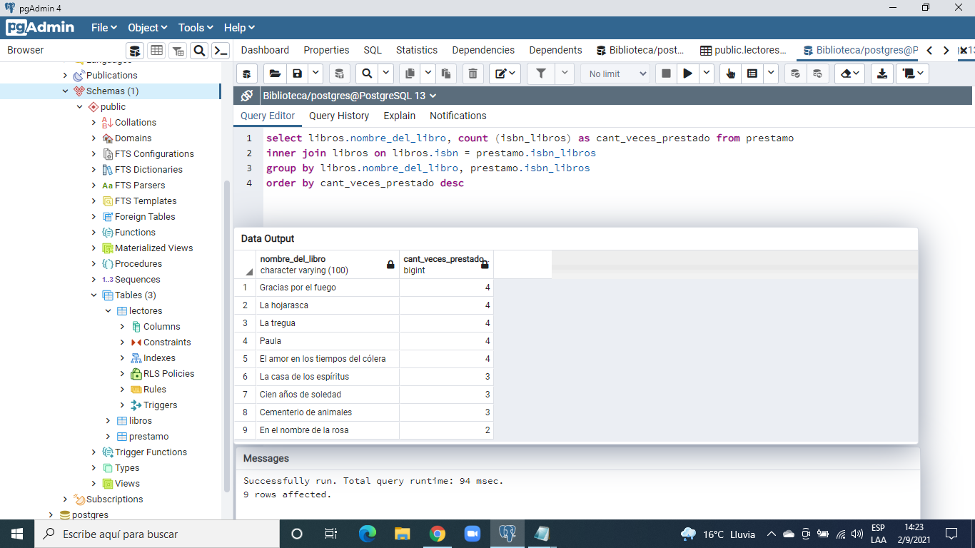

4. 1

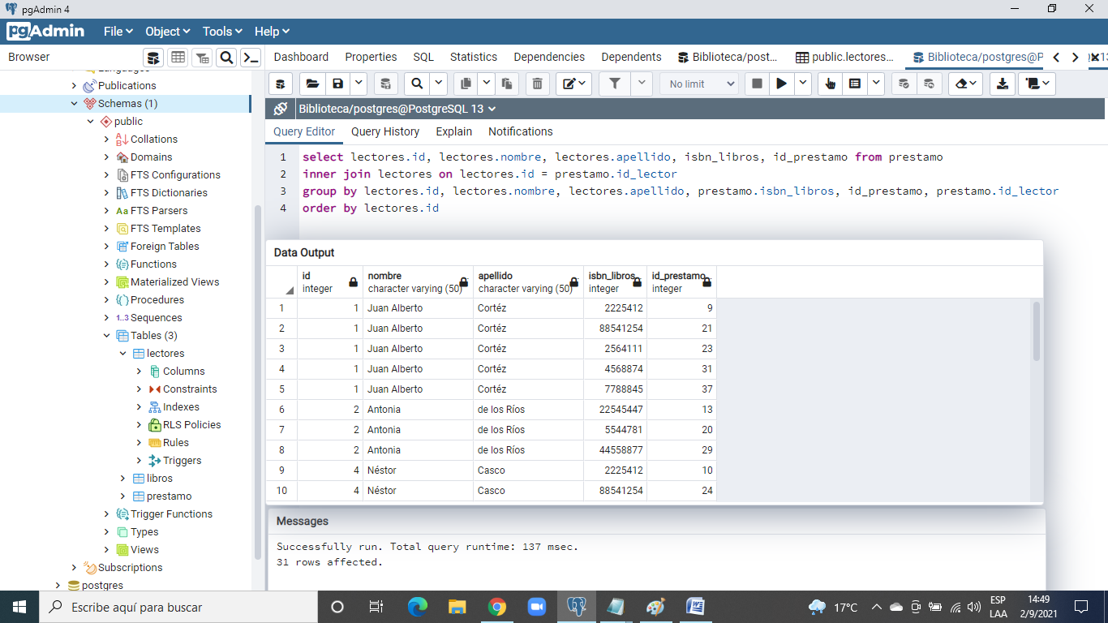

4.2

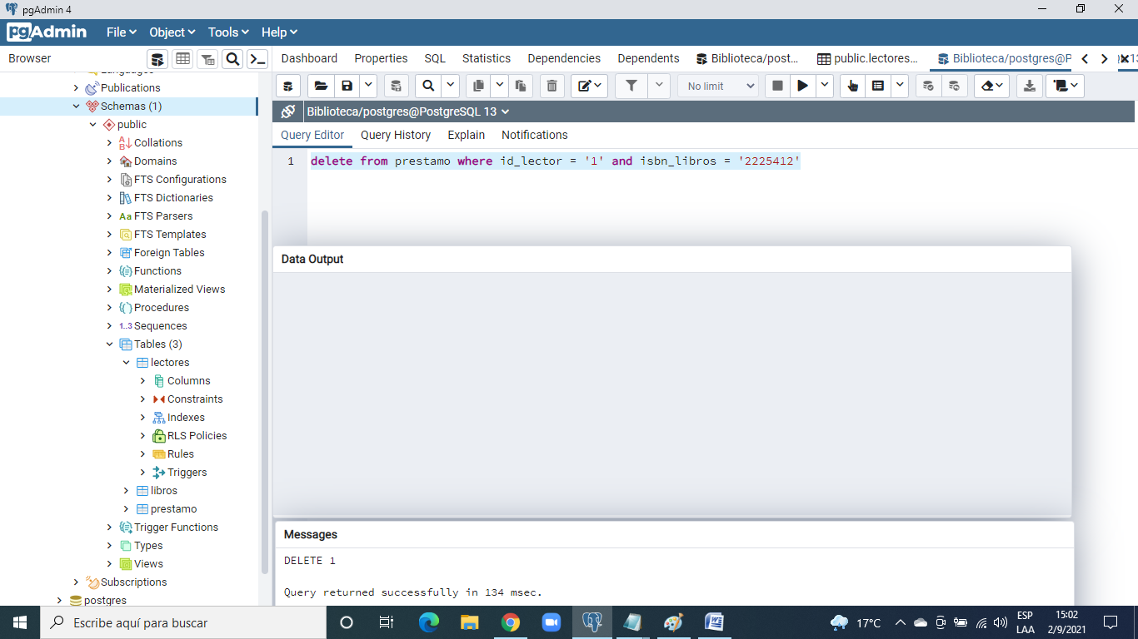

4.3

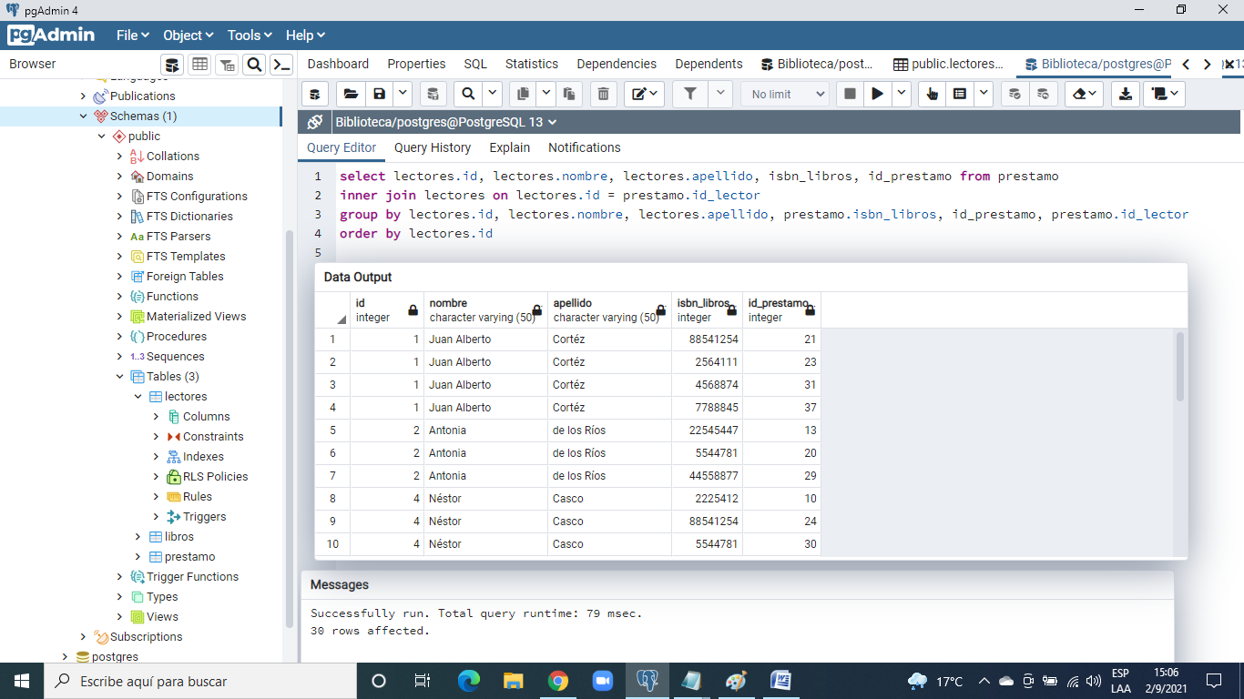

5.1

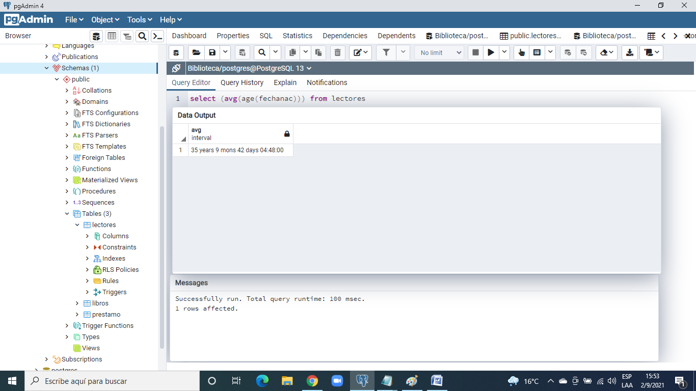

5.2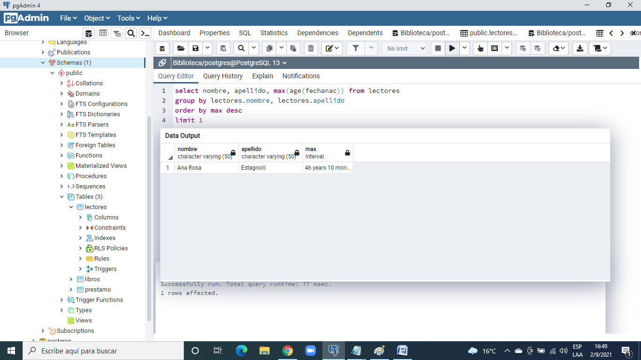

5.3

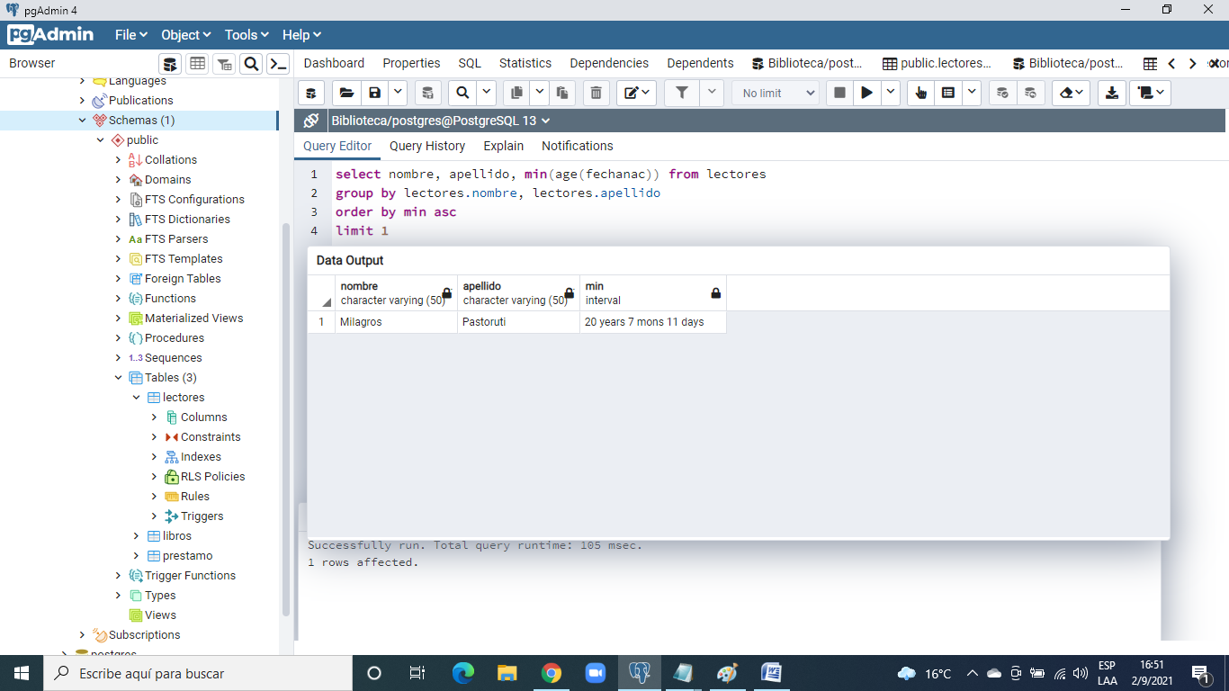

6. 1

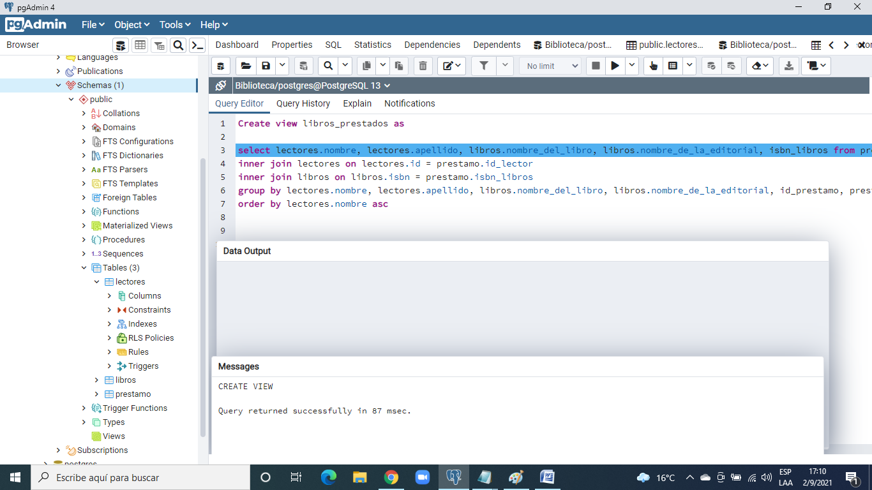

6.2

